|  |  |
| --- | --- |
| Date | 7 November 2022 |
| Team ID | PNT2022TMID09382 |
| Project Name | A Novel Method for Handwritten Digit Recognition System |
| Maximum Marks | 4 Marks |

**SOLUTION ARCHITECTURE**

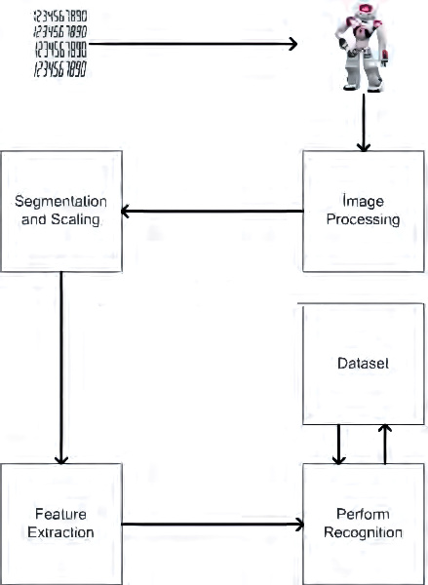

**MNIST dataset processing with python**

